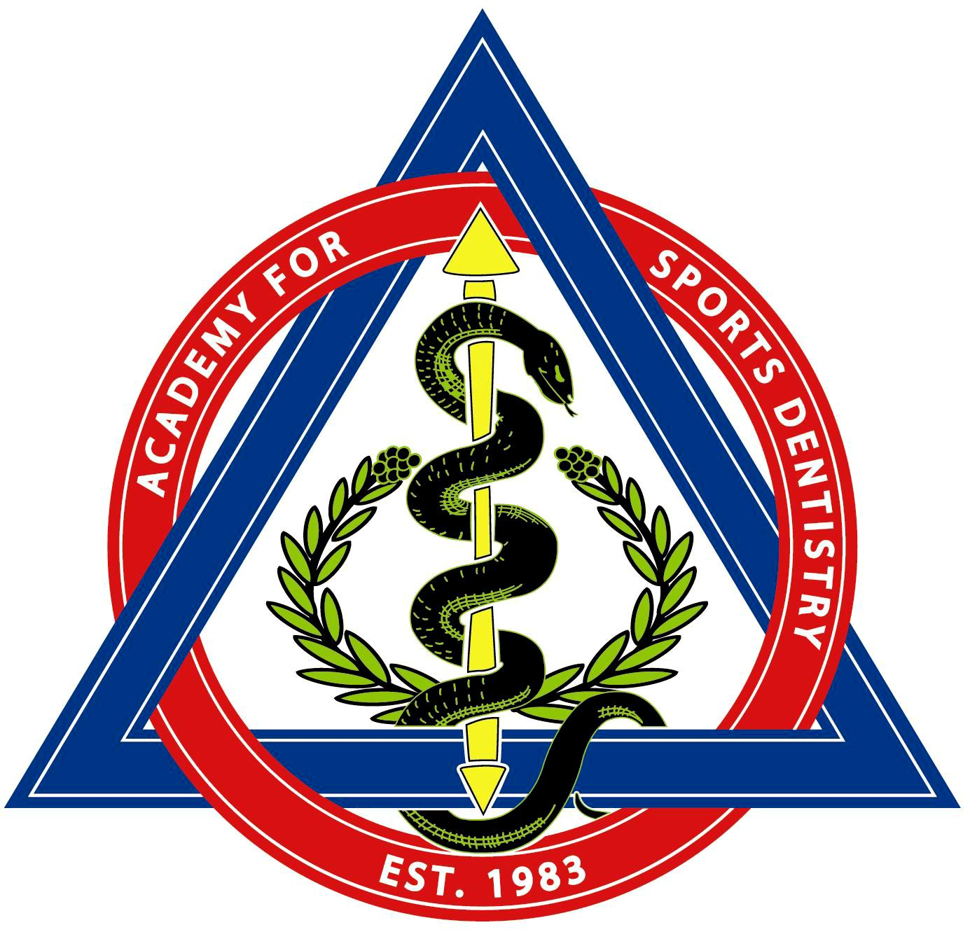

ENROLLMENT IN THE ASD FELLOWSHIP PROGRAM

Academy for Sports Dentistry
PO Box 1237
Cannon Beach, OR 97110
Telephone: (971) 303-8908
Email: info@academyforsportsdentistry.org
www.academyforsportsdentistry.org

I wish to apply for the ASD Fellowship. I have included payment of $25.00 (US Funds) registration fee.

Name_________________________________________________________________________

Address______________________________________________________________________

City __________________________________________________________________________

State_____________________ Zip _________________Country_________________________

Telephone _______________________________Fax _________________________________

Email ________________________________________________________________________

Year joined ASD _______________________

